**Detroit Tigers Performance Science Questionnaire**

Please answer the below questions to the best of your ability. Please adhere to the word limit of 300 words per question and save the file with your last name in the title.

1. From a performance science perspective, describe a project you believe would add substantial value to the Detroit Tigers. Please describe the project and provide an overview of how you would complete it.
2. Workload monitoring is a popular topic in Performance Science. With the introduction of in game-tracking data in addition to technology used in practice, the available data for modelling workload and injury prediction is immense.
   1. The medical director has asked you to track workload for short stop who is particularly prone to injury. Outline the steps you would take, including metrics of interest to generate an overall workload metric for this player.
   2. Using this workload metric, and any other data/information of value, what modelling technique(s) would you employ to assess the possibility of future injury?
3. Players A, B, and C are available to acquire (for this exercise assume positions are inconsequential, they are all the same handedness, that they are the same age and of similar cost). Please rank them from the player you are most interested in, to least interested in. Explain your reasoning. 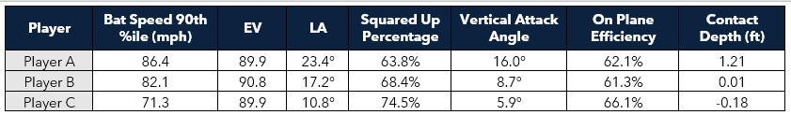

*Note: Contact depth is relative to front of home plate.*

1. A scout has sent you the motion tracking data (biomechanical data) from a college prospect the team is strongly considering drafting:
   1. Outline the process you would use to assess this data and provide a brief overview of what you would report back to the scout.
   2. Long term, what methods/models would you employ to determine if a high school prospect has the potential to generate a high velocity fastball? Assuming you have access to biomechanical data, statistics etc.
2. A coach asks you to investigate a pitcher with high variance in their FB velocities. Please produce a short self-explanatory report to answer the coach’s question. Include all code/workbooks. “PitchingData.csv” contains biomechanical pitching data for that pitcher across 7 outings on a play level. “Glossary.pdf” is a description of each biomechanical metric.